**SOUND CONTROLLED LED**

**Introduction**

Sound sensors can be used for a variety of things, one of them could be turning lights off and on by clapping. Today however we are going to use hook up the sound sensor to an array of LED lights which will beat with music, clapping or knocking

The sound sensor is a small board that combines a microphone (50Hz-10kHz) and some processing circuitry to convert sound waves into electrical signals.

This electrical signal is fed to on-board LM393 High Precision Comparator to digitize it and is made available at OUT pin. The module has a built-in potentiometer for sensitivity adjustment of the OUT signal.

You can set a threshold by using a potentiometer; So that when the amplitude of the sound exceeds the threshold value, the module will output LOW otherwise HIGH.

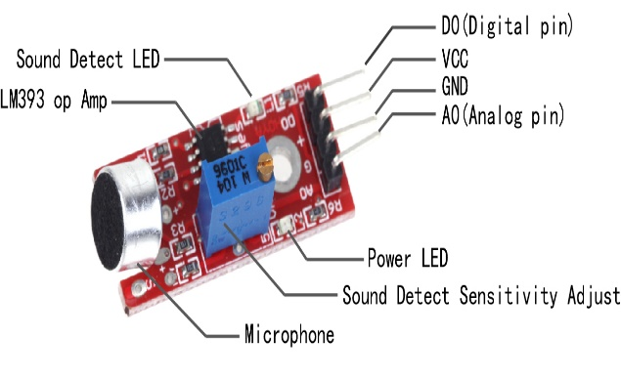Components

* Arduino
* A Sound Sensor
* LED
* 220 ohm Resistors
* Mini Breadboard
* Wires

Application

Consumer electronics such as phones, computers, music systems.

Security and Monitoring systems such as burglar alarms, door alarm, etc

. Home automation such as lighting your house by detecting whistle/clap instead of physically turning the light switch.

Ambient sound recognition and sound level recognition

Objective

During this activity ,you will help students to achieve following objectives

1. Understanding the principle and operation of sound sensor

2. Design algorithm and flowchart to detect sound waves and LED will blink

3. Programming sound sensor using Arduino uno

4. Interfacing sound sensor withArduino uno

**Programming steps**

1. Initialise sound sensor input pin
2. Initialise LED as digital output pin
3. Define sound sensor as input
4. Define LED as output
5. Initialise status sensor to read value of input data
6. Read input value of sound sensor
7. If status sensor is HIGH, blink LED .

**Programming**

int soundSensor = 2;

int LED = 4;

void setup()

{

  pinMode (soundSensor, INPUT);

  pinMode (LED, OUTPUT);

}

void loop()

{

  int statusSensor = digitalRead (soundSensor);

  if (statusSensor == 1)

  {

    digitalWrite(LED, HIGH);

  }

  else

  {

    digitalWrite(LED, LOW);

  }

}

Hardware

INSTRUCTION

1. Connect VCC of sound sensor to the 5v supply voltage pin
2. Connect signal out pin of sensor digital input pinD3 of arduino.
3. Connect Gnd pin of sensor to LED cathode
4. Positiveoin of LED is connected to the digital input pin D5 of arduino
5. Ground pins of led connect to the ground of arduino.
6. Connect the arduino and upload the program arduino uno.

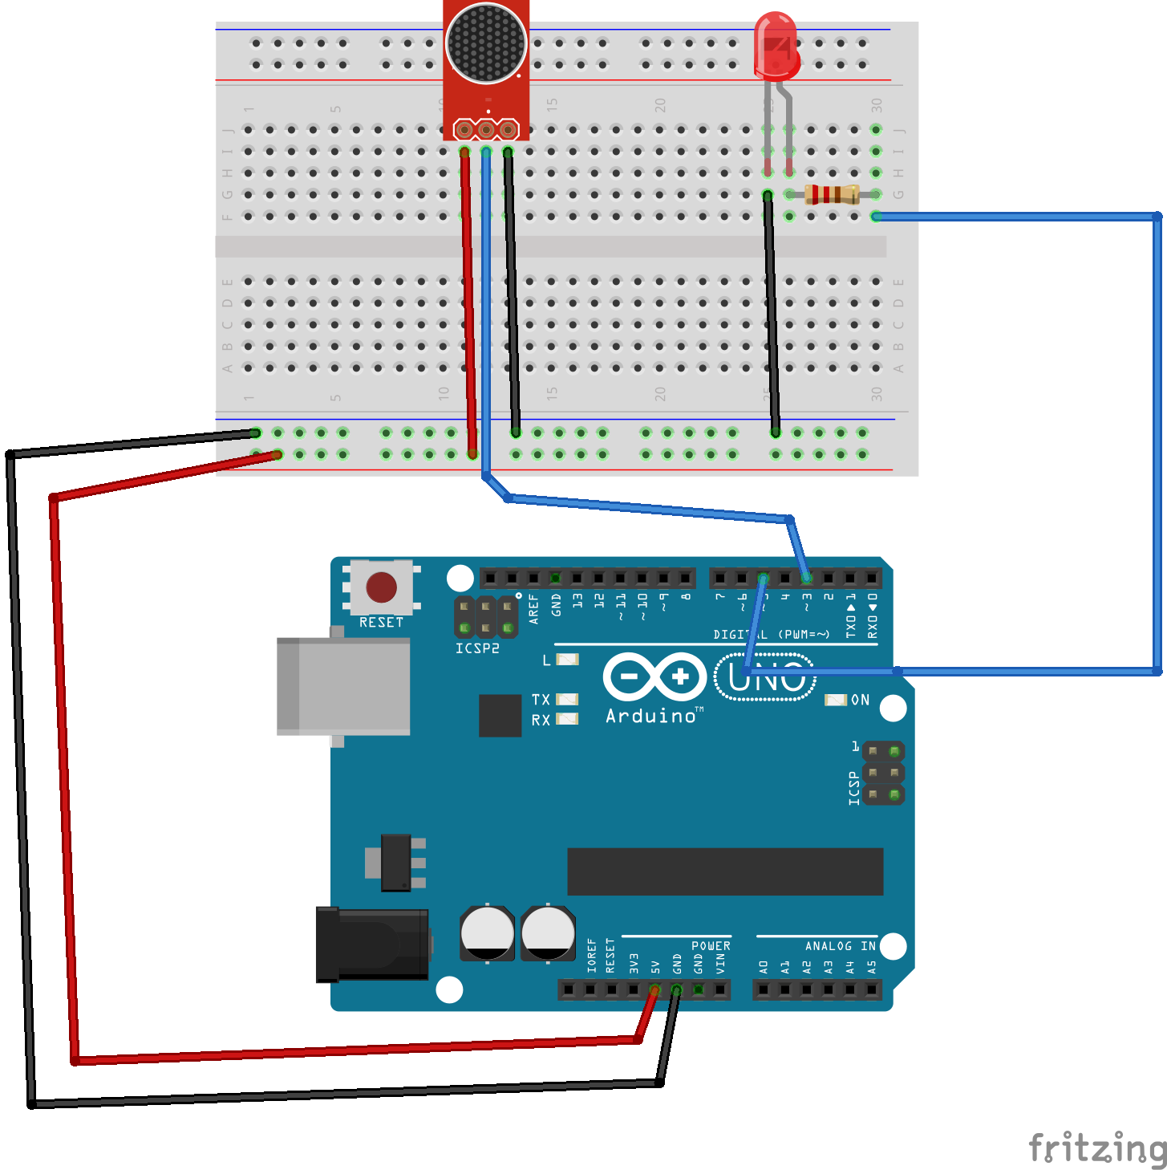

Circuit diagram

